**Experiment no 8**

**Name:-Shaikh Masood Iqbal**

**Roll no:-24DDS02**

**AIM:** To design and Simulate VLANs on the switch/router using Cisco packet tracer/ GNS3.

**REQUIREMENTS:** CISCO Packet Tracer

**THEORY:**

A Virtual LAN (VLAN) is simply a logical LAN, just as its name suggests. VLANs have similar characteristics with those of physical LANs, only that with VLANs, you can logically group hosts even if they are physically located on separate LAN segments.

We treat each VLAN as a separate subnet or broadcast domain. For this reason, to move packets from one VLAN to another, we have to use a router or a layer 3 switch.

VLANs are configured on switches by placing some interfaces into one broadcast domain and some interfaces into another. For this tutorial, we’ll configure 2 VLANs on a switch. We’ll then proceed and configure a router to enable communication between the two VLANs.

Procedure:-

1. In Cisco Packet Tracer, create the network topology as shown below:

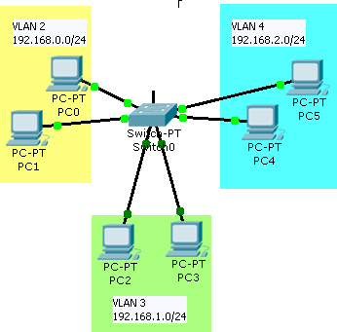

2. Create 2 VLANs on the switch: VLAN 10 and VLAN 20. You can give them custom names.

Switch#enable

Switch#config terminal

Switch(config)#vlan 10

Switch(config-vlan)#name SALES

Switch(config-vlan)#vlan 20 Switch(config-vlan)#name IT

3 Assign switch ports to the VLANs. Remember each VLAN is viewed as separate broadcast domain.

Switch>enable Switch#config terminal

Switch(config)#interface fast ethernet 0/1 Switch(config-if)#switchport access vlan 10 Switch(config-if)#exit

Switch(config-if)# interface fast ethernet 0/2 Switch(config-if)#switchport access vlan 10 Switch(config-if)#exit

Switch(config-if)# interface fast ethernet 0/3 Switch(config-if)#switchport access vlan 20 Switch(config-if)#exit

Switch(config-if)# interface fast ethernet 0/4 Switch(config-if)#switchport access vlan 20 Switch(config-if)#exit

Switch(config)#exit

Switch(config)#copy running-config startup-config

4. Assign static IP addresses to the four

PCs which are located in separate VLANs. PC1 and PC2 fall in VLAN 10 while PC3 and PC4 fall in VLAN 20.

PC1 IP address 192.168.1.10 Subnet mask 255.255.255.0 Default gateway 192.168.1.1

PC2: IP address 192.168.1.20 Subnet mask 255.255.255.0 Default gateway 192.168.1.1

PC3: IP address 192.168.2.10 Subnet mask 255.255.255.0 Default gateway 192.168.2.1

PC4: IP address 192.168.2.20 Subnet mask 255.255.255.0 Default gateway 192.168.2.1 And now it’s very clear that we treat a VLAN just like a physical LAN when assigning IP addresses.

At this point let’s try to test connectivity within VLANs and between VLANs To test communication between hosts in the same VLAN:

Ping PC2 from PC1 both in VLAN 10. The Ping test should be successful.

**OUTPUT:**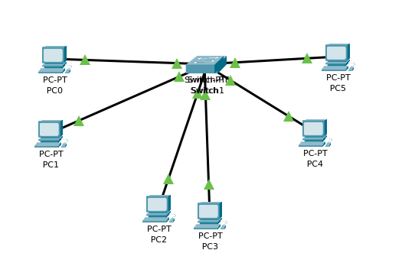

**CONCLUSION:** We have studied what is VLAN and Design VLAN using Cisco Packet tracer.